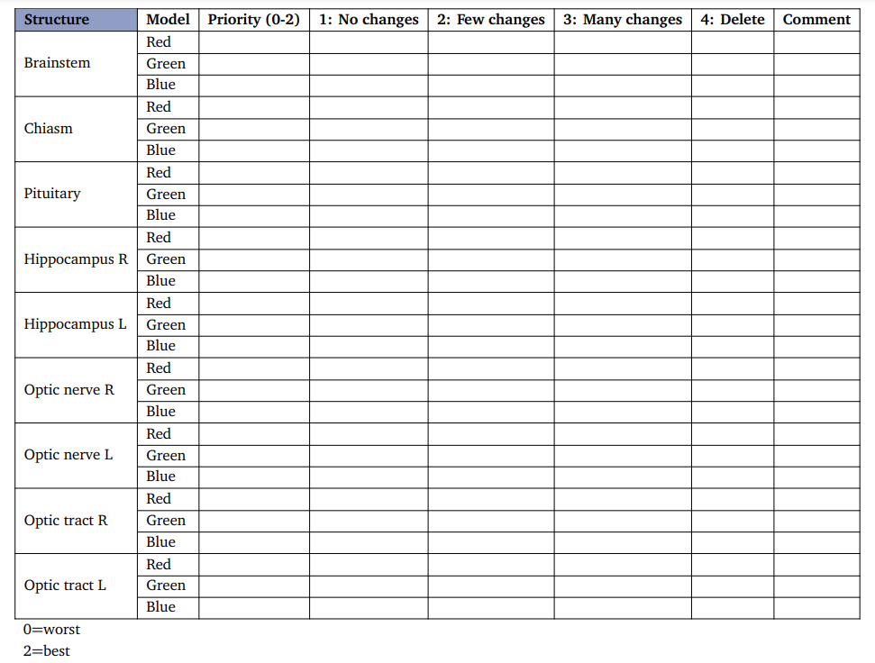

Hi ingrid

Here is the recommendation letter we initially used when receiving the funds for the trip. I am unsure if this is sufficient as a secondary recommendation letter. In addition to this there is attached a copy of my drivers license which could be used as the secondary ID.

I am still waiting on the letter from the tenant; however, I have received confirmation that they will provide one.